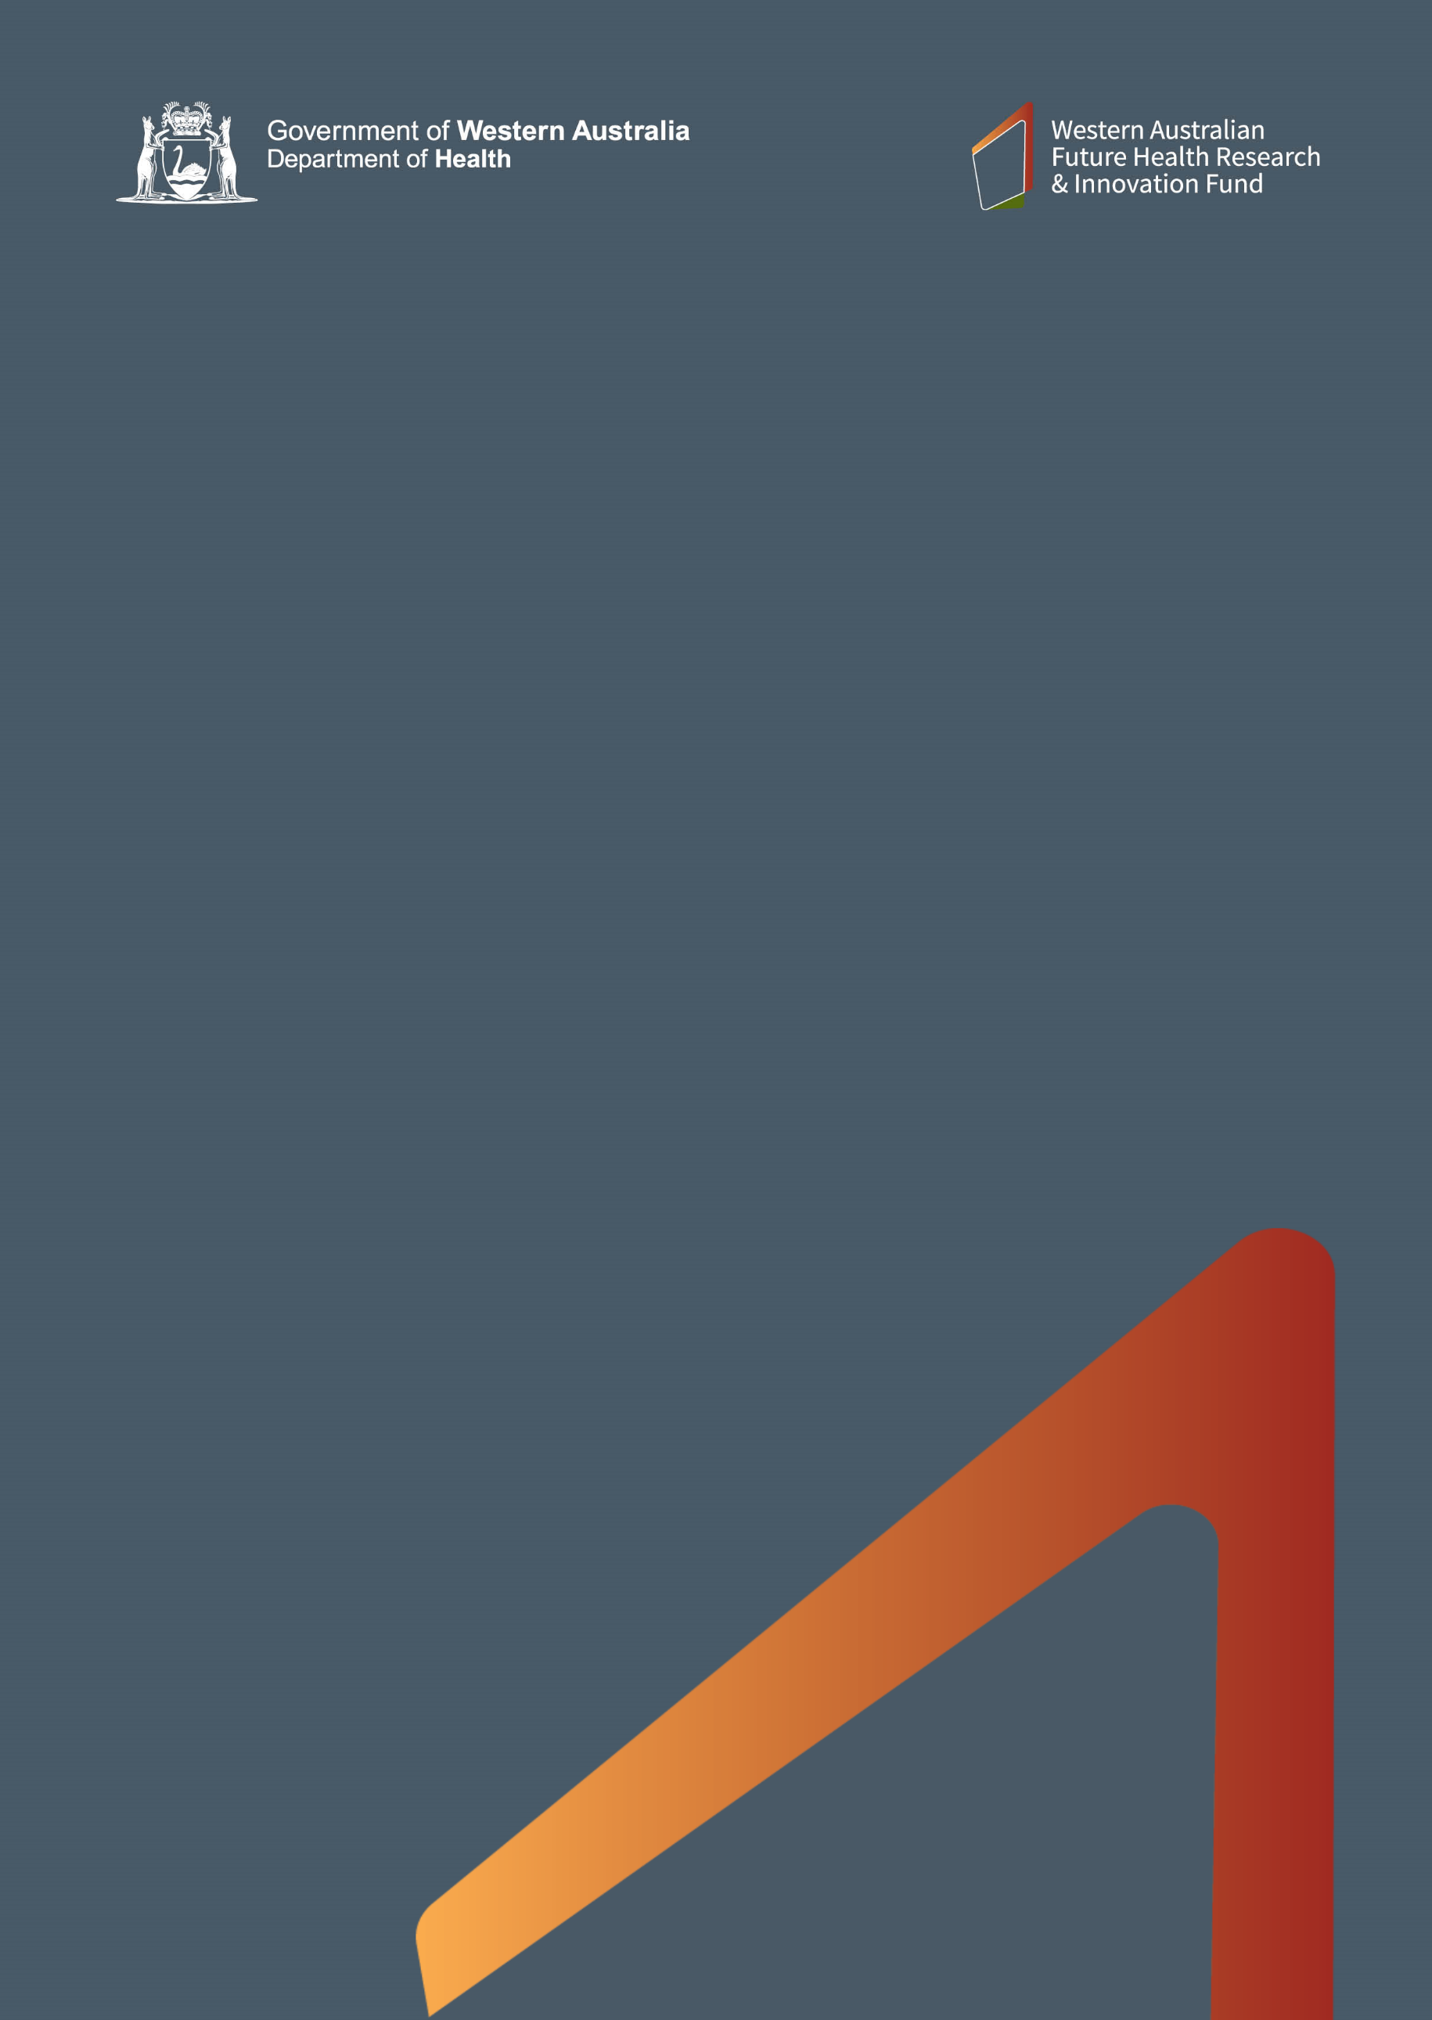

WA Near-miss Awards 2021

Application Form

Closing Date: 1.00pm, Tuesday 2 March 2021

fhrifund.health.wa.gov.au

WA Near-miss Awards 2021

Application Instructions

Applications Close: 1:00pm Tuesday 2 March 2021

LATE APPLICATIONS WILL NOT BE ACCEPTED

Check with the research administration office for internal deadlines

- Applications are invited in accordance with the conditions described in the WANMA 2021 Guidelines and Conditions which are available at: https://fhrifund.health.wa.gov.au/Funding/Current-opportunities/WA-Near-miss-Awards-2021

- Do not submit the Application Instructions page with the Application Form.
- Applicants are asked to submit their application through the administering institution’s research administration office and are responsible for checking internal deadlines.
- All required administrative sign-offs and approvals must be provided at the time of submission.
- Electronic signatures and initials are acceptable. The onus is on the applicant to ensure approval to use an electronic signature/initial has been obtained.
- Acknowledgment of receipt of application will be provided via e-mail to the research administration office within two working days of the closing date.
- The application is to be emailed to RIO.DOH@health.wa.gov.au as a single Adobe Acrobat PDF or Microsoft Word file, not exceeding 2MBs. The application and email subject line should be titled as follows:
Applicant SURNAME First name – WANMA 2021
e.g. SMITH John – WANMA 2021
- For queries please contact the Research and Innovation Office, WA Department of Health via email RIO.DOH@health.wa.gov.au.

WA Near-miss Awards 2021

Application Form

Section 1: Applicant details

Title
First Name
Surname
Email Contact
Phone Contact

Section 2: NHMRC near-miss application details

Application Title
NHMRC Application Type | Choose an item.
NHMRC Application Number
NHMRC Application Budget
Duration of NHMRC grant applied for
NHMRC Application Score
Please list the application score to two decimal places.
Administering Institution

Section 3: Confirmation of eligibility

I confirm by checking the boxes below that the following is correct:
(please click on the boxes to create a checkmark)

NHMRC application
☐ The NHMRC application as listed in Section 2 was assessed as being ‘fundable but not funded’ by the NHMRC peer review panel in one of the following rounds:
- Ideas Grants 2020 Funding Round
- Investigator Grants 2020 Funding Round – Emerging Leadership Stream 1
- Investigator Grants 2020 Funding Round – Emerging Leadership Stream 2
☐ The NHMRC application as listed in Section 2 received a score within Category 5.

Chief Investigator
☐ I reside in Western Australia.
☐ I do not hold a full professorial position in any Australian university.
☐ I do not have any outstanding reports for any WA Department of Health (DoH) grant funding programs from any years (excludes authorised extensions).

ONLY IDEAS GRANTS APPLICANTS NEED TO ANSWER THIS QUESTION
☐ I have never been awarded funding from the DoH Medical and Health Research Infrastructure Fund (MHRIF).

Section 4: Previous WA Department of Health funding

Please select one of the two options below in relation to the application listed in Section 2:

☐ I have never received funding from the DoH for activity under this project or for a substantially similar project.
☐ I have received funding from the DoH for a similar or related project and require an assessment to determine if it is eligible for WANMA funding. WANMA funding will only be provided if the application listed in Section 2 includes substantial new work.

Project Title
Grant Program Name and Round

Section 5: Other funding
Please select one of the two options below:

☐ I have no other current source of funding for this project and I have no related funding applications presently under review by another funding body.
☐ I have applied for or have received other funding for this project (provide details below).
For multiple funding applications, please provide each in a separate table.

Funding Organisation
Funding Scheme/Round
Funding Status | Choose an item.
Amount of Funding
Date of Award or Decision
Start and End date of Funding

Section 6: Certification by Chief Investigator

- I declare that the information supplied by me on this form is complete, true and correct in every particular.

- I agree to abide by the WA Near-miss Awards 2021 Guidelines and Conditions.

- I agree to obtain the relevant research governance approvals and agreements before commencement of the project.

- I understand and agree that no further claim will be made on the DoH to cover any over-expenditure of budget or any costs beyond the research project.

Full Name
Signature | Date

Section 7: Certification by Administering Institution

I declare that:

- The administering institution endorses the application proposed by the applicant and is willing to administer the grant under the conditions specified by the DoH in the WA Near-miss Awards 2021 Guidelines and Conditions.

- The administering institution will ensure all relevant and applicable research ethics and institutional governance approvals are in place for the project prior to any funded activities commencing.

- The Research and Innovation Office, DoH will be notified immediately of any changes to the applicant’s eligibility (e.g. employment status) or changes to the information originally provided in this application.

Title, First Name, SURNAME
Position
Institution
Signature
Date
Telephone number(s)
Email address
n be made available in alternative formats on request for a person with disability.

Produced by the Research and Innovation Office
© Department of Health 2021

Copyright to this material is vested in the State of Western Australia unless otherwise indicated. Apart from any fair dealing for the purposes of private study, research, criticism or review, as permitted under the provisions of the Copyright Act 1968, no part may be reproduced or re-used for any purposes whatsoever without written permission of the State of Western Australia.

